Instructions:

# Move motor manually:

* Press w to move stage up
* S to move stage down
* Q to decrease step
* E to increase step

# Change LED brightness:

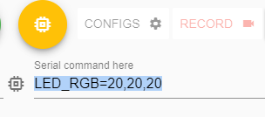

Type command:

* LED_RGB=x,y,z (default is 10,10,10)
* To change the default value, refer to section “Change Camera settings”

# Start autofocusing:

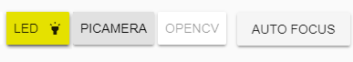

* Press Auto Focus

You will have to wait for about 100 seconds for the whole process.

After the auto focusing finish, click

* Press PICAMERA to resume the default streaming interface before timelapse

# Timelapse:

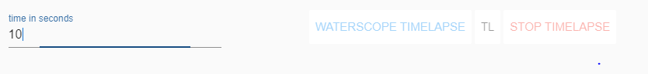

* Change the timelapse interval here in seconds

For 20 min = 20*60 = 1200

* Press WaterScope Timelapse (this refers to the timelapse that turns on and off LED)
* Wait for 20 sec before Closing the web browser if you want
* Press STOP TIMELAPSE to stop any pre-existing process

# Take photos



* Low res is the normal JPEG
* High res is the raw image

# Change Camera settings

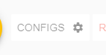

* Press Configs
* In Cyberduck, modify the file



* Save the file and the effect will be shown immediately

# For alex

To start the web interface in the beginning:

* In terminal:
  + crontab -u pi -e
* at the bottom of the file add the line
  + @reboot bash /home/pi/WaterScope-RPi/sh_command/start_interface.sh